March, 30, 2016

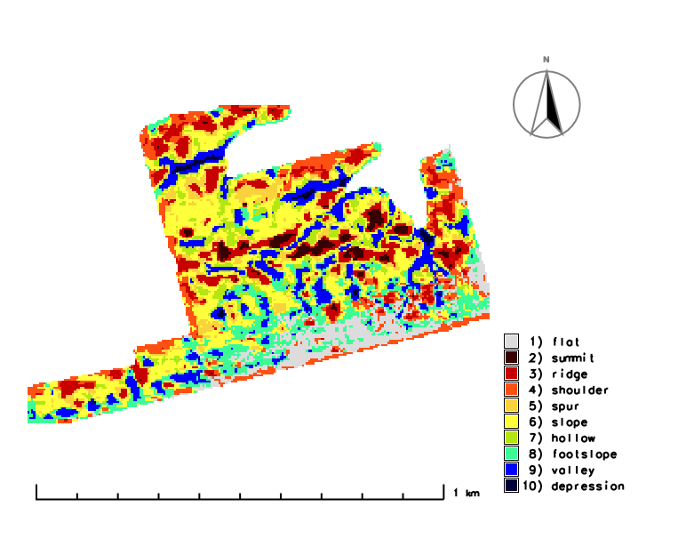

GeomorphonS Assesment in Grass GIS

Travis Vanos

## 1.1 Crop Portal Kriged Data

Using the kriged points from the crop portal (<http://globalfarmmanager.ca/>) the **shapefile** (.shp) was downloaded and saved. The shapefile, along with the projection (.prj) were imported into both GRASS GIS and ArcGIS. The following parameters can be seen in Figure 1:

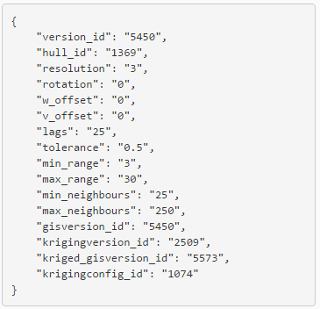

Figure 1 Portal Krige Settings

## 1.2 Crop Portal vs GrassGIS Geomorphons

### 1.2.1 Importing Point Data from Crop Portal

The kriged data was imported in a shapefile (.shp) format. Points contain Easting(x), Northing(y) and elevation(z) data. The point data were then converted to raster **(*v.to.rast).*** Figure 2 shows kriged points converted to raster in GrassGIS.

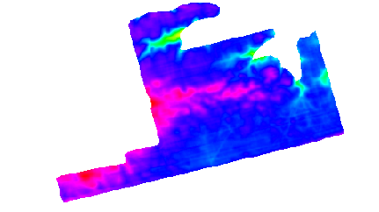

Figure 2 Rasterized Kriged Elevation Points (Crop Portal)

After the raster was produced, the geomorphons extension was added to GrassGIS using the extension manager (**r.geomorphon)**. After which the landform was classified into the 10 categories of landform classification. The default geomorphon settings were replicated in GRASS GIS as seenin Figure 3.

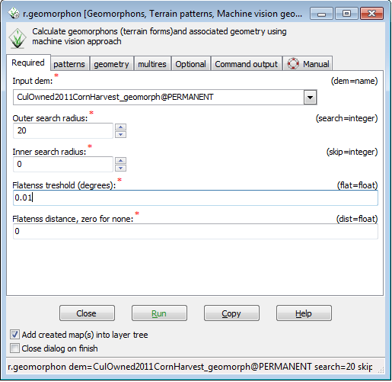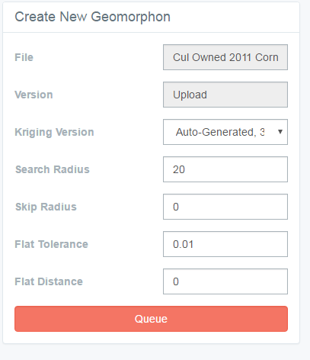

Figure 3 GrassGIS and Crop Portal Geomorphons Classification

After which a raster was created for further investigation. The two raster images can be seen in Figure 4

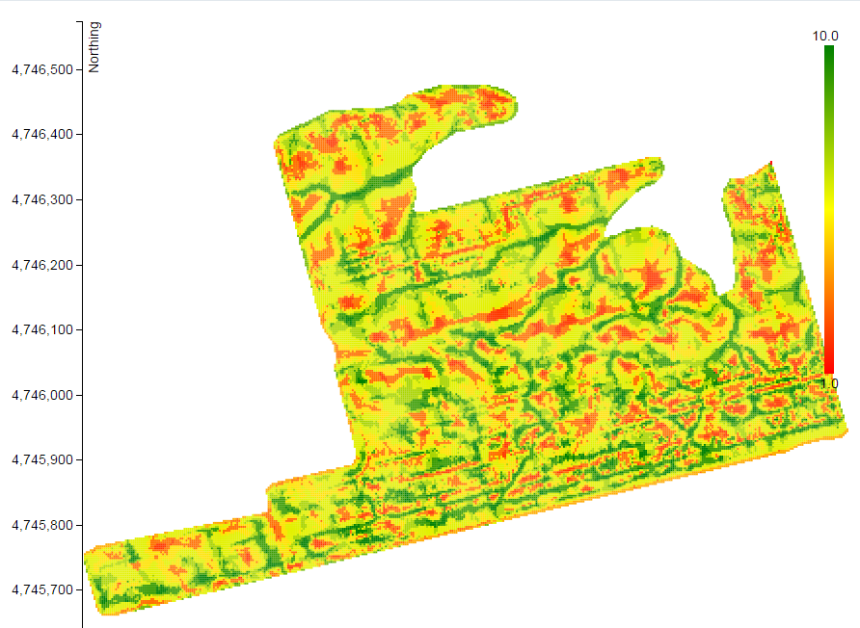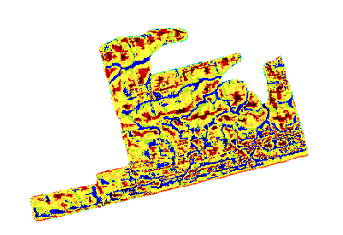

Figure 4 Porta Raster (left)l vs GrassGIS Geomorphon Rater (right)

.

### 1.2.2 Verifying GrassGIS Vector and Raster Import in ArcGIS

To eliminate the possibility for discrepancies with the point to raster tools in both ArcGIS and GRASS GIS, a raster created in ArcGIS was compared to a raster created in GRASS GIS. The created raster (**.tif** ) file and a point data (**.shp**) were imported to ArcGIS. The point feature class was converted to raster in ArcGIS (**Pont to Raster** tool). The output raster was classified using the known table reflecting the geomorphon land classifications (Landform classification 1-10) used in GRASS GIS’s r.geomorphon tool, Figure

Figure 5 R.Geomorphon Landform Classification

The created raster and the **.tif** raster exported from GRASS GIS were compared using the ***Diff*** tool in ArcGIS to ensure no irregularities with vector to raster conversion in ArcGIS and GrassGIS. The result were two identical raster inputs as seen in Firgure 6, black representing `0` value meaning no change has occurred.

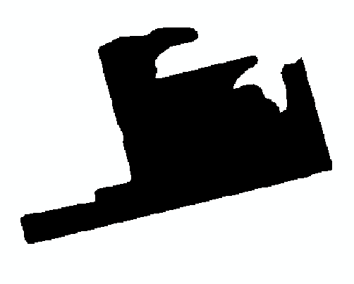

Figure 6 Diff Result of GrassGIS Vector vs Raster Map

### 1.2.3 Importing Portal Vector Map in ArcGIS

After verifying no issues would arise with the point to raster conversion, the created portal geomorphon was produced and the point feature class was imported into ArcGIS and converted to a raster (**point to raster** tool). Creating a symbology classification with 10 breaks (Landform classification 1-10 used in GRASS GIS’s r.geomorphon tool) should display the same result as the portal.

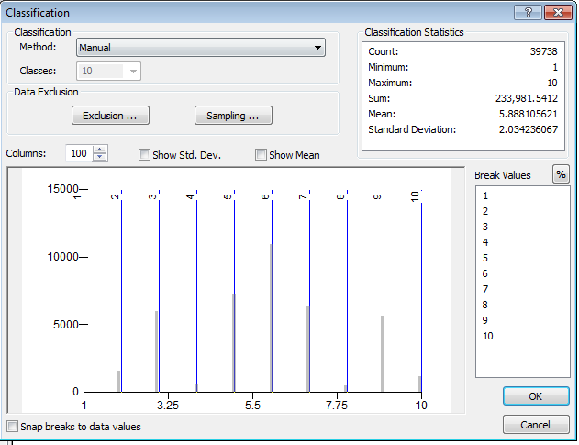

Figure 7 Creating 10 Breaks for Landform Visulization

## 1.3 Results

After the two rasters have been produced (ArcGIS’s reclassified raster and GRASS GIS r.geomorphon), they are then compared with ArcGIS ***Diff*** tool for comparing the two raster datasets. The diff tool revealed 31,022 cells identical, 8659 different (Black).

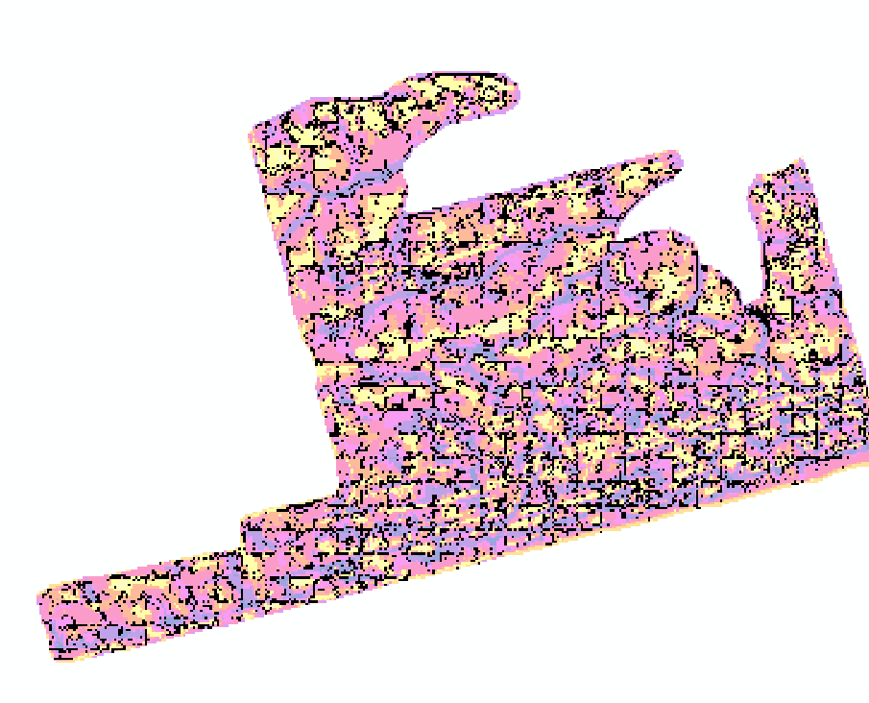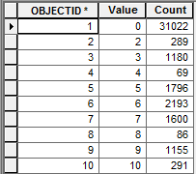

Figure 8 Produced Diff Raster Showing Geomorphon Irregularities